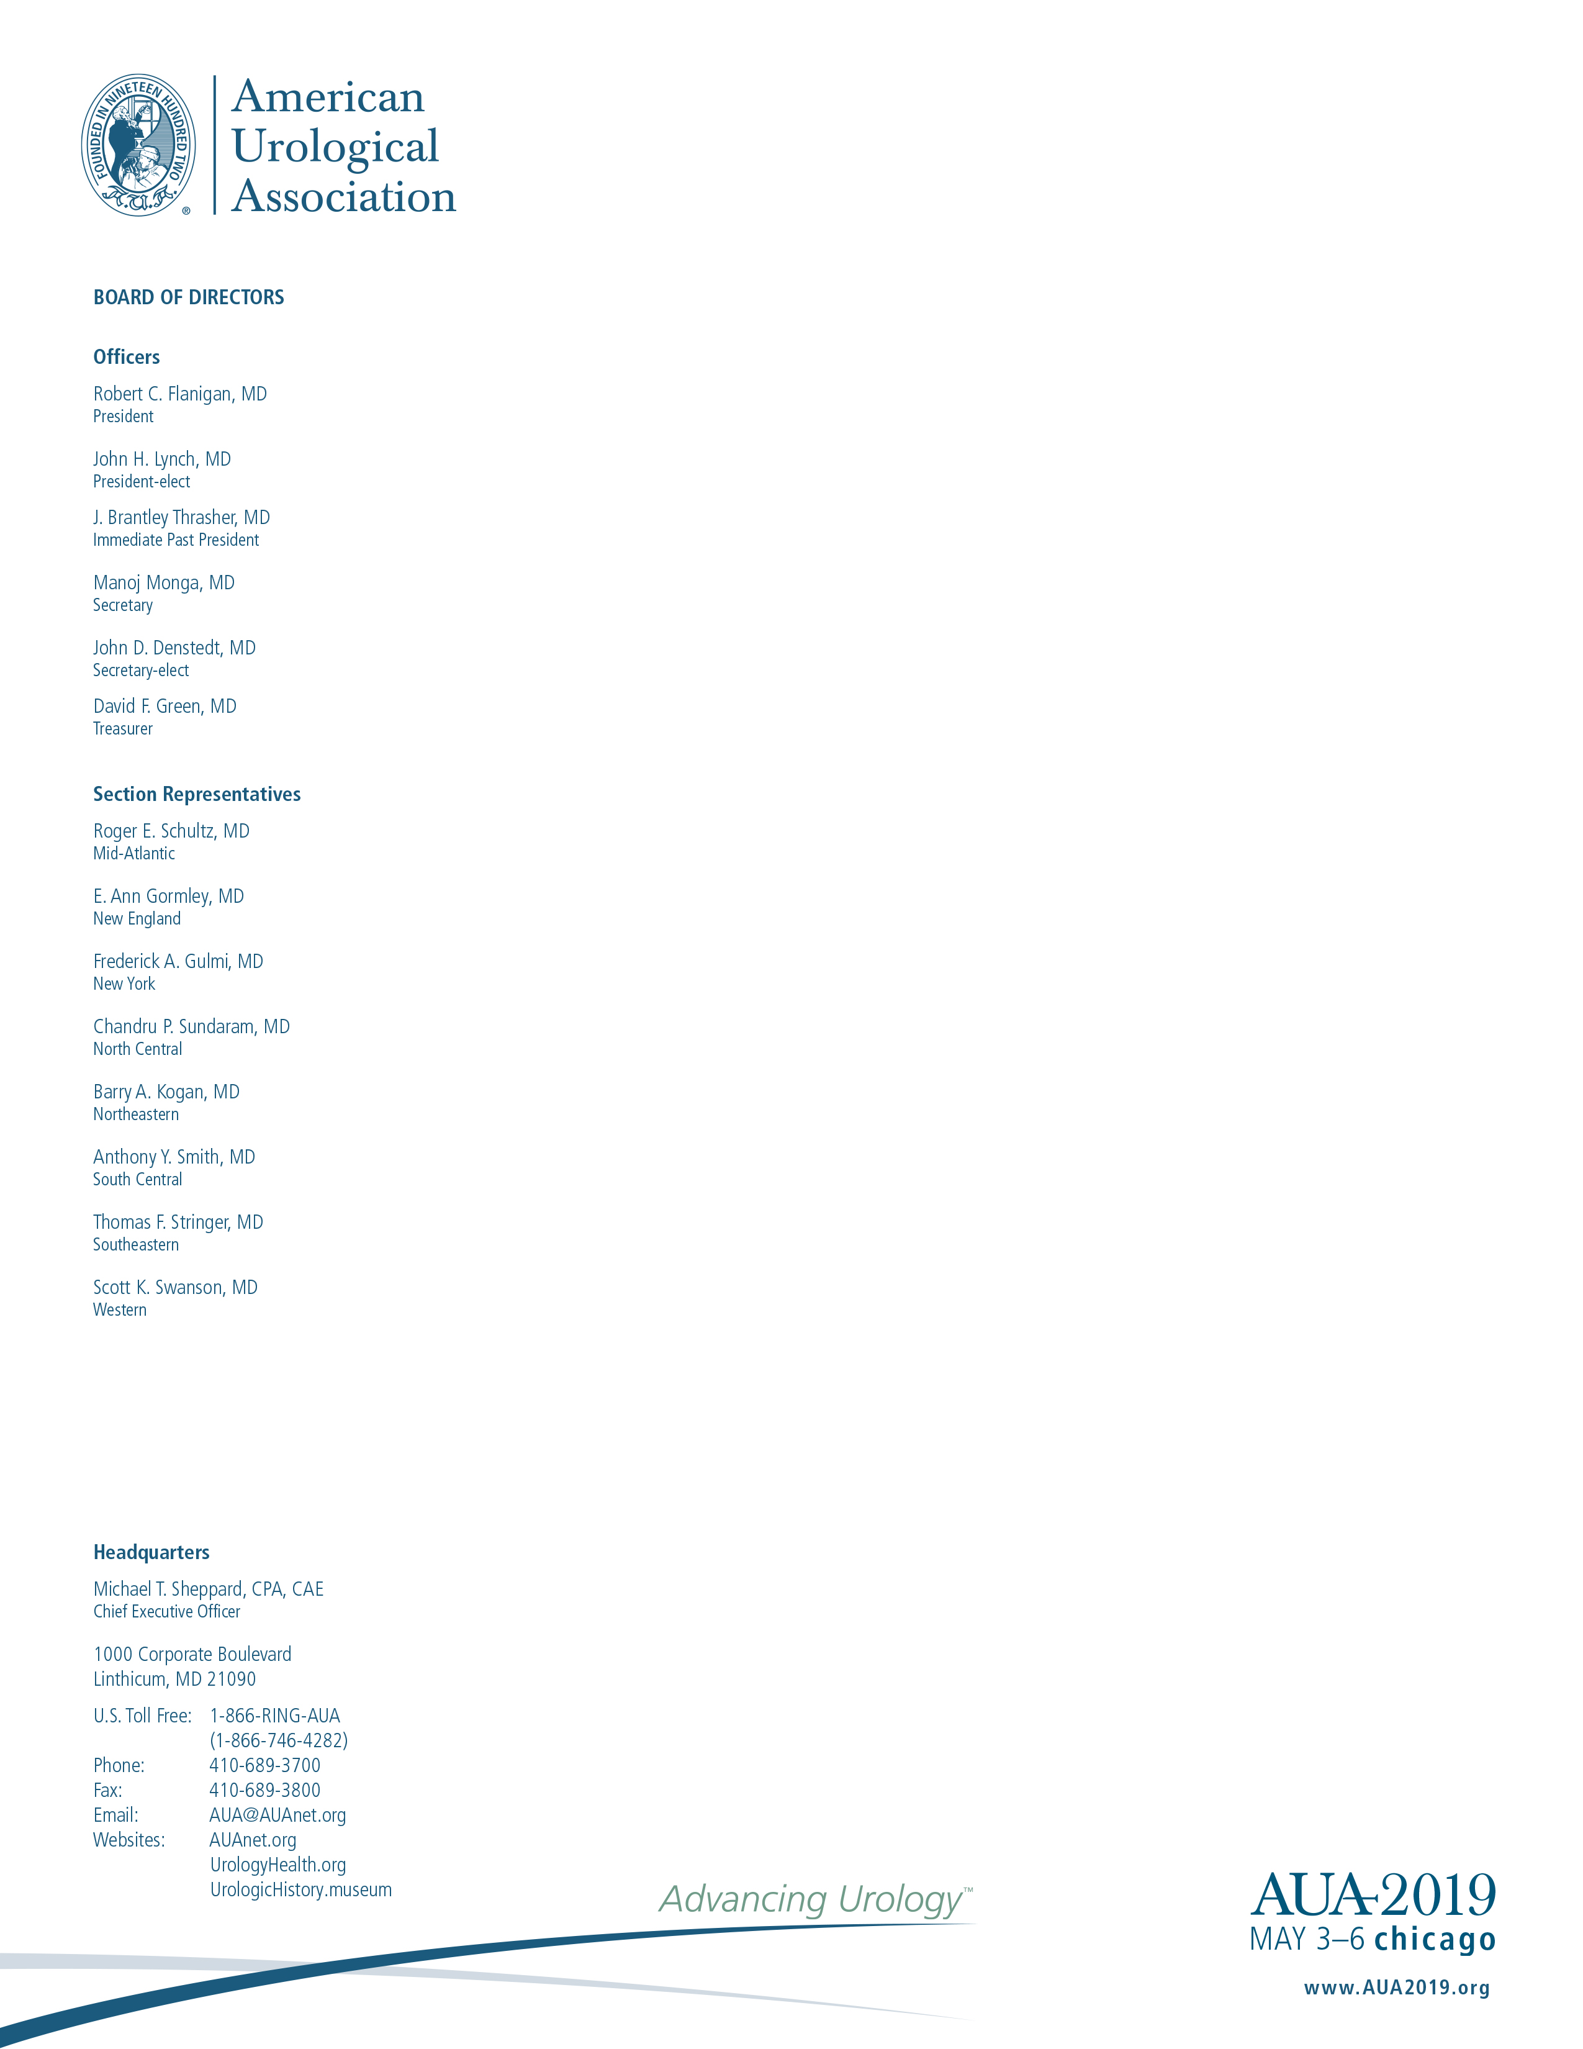
January 7, 2019

Donald W. Rucker, MD
National Coordinator for Health Information Technology
Office of the National Coordinator for
Health Information Technology

Dear Dr. Rucker:

The American Urological Association (AUA) is a globally-engaged organization with more than 22,000 members practicing in more than 100 countries. AUA members represent the world's largest collection of expertise and insight into the treatment of urologic disease. Of the total membership, more than 15,000 are based in the United States and provide invaluable support to the urologic community by fostering the highest standards of urologic care through education, research and the formulation of health policy.

The AUA is in general agreement with the principles laid out in the draft Strategy on Reducing Regulatory and Administrative Burden Relating to the Use of Health IT and EHRs. The document provides a comprehensive summary of the major issues associated with the use of electronic health records (EHR) and highlights areas where the technology should change. The AUA urges enforcement of these recommendations to ensure vendors comply while also taking into consideration the burden on providers. Each version change for EHR products is a significant expense for providers. Furthermore, vendors are often not responsive to the needs of provider practices. Therefore, the Office of the National Coordinator for Health Information Technology and the Centers for Medicare & Medicaid Services must advance this strategy in order to improve efficiency and ultimately impact quality of care.

Thank you for your consideration of this feedback.

Sincerely,

Christopher Tessier, MD
Chair
EHR Workgroup

